CenturyLink EASE ASR
ADMIN GUIDE

Version - Revision History

All versions of this document are listed in chronological order:

ASOG Version | Date | Description
58.0 | 03/16/2019 | Final

Historical Information | All historical documentation this publication can be found at: http://www.centurylink.com/wholesale/systems/ossconsolid.html

Table of Contents

EASE System Overview 4
Whom to Call and When 4
CenturyLink IT Wholesale Systems Help Desk Roles and Responsibilities 4
ORDER TAB 7
ADMINISTRATION TAB 8
User Profile 9
Searching for a specific user or group 10
Using a wildcard in the search 11
Adding a New User 12
Modifying an Existing User 15
Resetting a Locked User 17
Resetting an Inactive User 19
Deleting an Existing User 21
Display Groups 22
Searching for a specific Display Group 22
Using a wildcard in the search 23
Creating a New Display Group 23
Modifying a Display Group 24
Bulk Reassign 26
Deleting a Display Group 28

EASE System Overview

Overview | The EASE ASR Administrator’s guide provides additional information regarding security privileges to search, create and modify Users. This guide is intended to compliment the information provided the EASE ASR User Guideline and will focus on the system functionality contained on the ADMINISTRATION tab.

Whom to Call and When | If you need an account created or changes to your CCNA permissions or personal information (name, email address, etc.), contact your EASE system Administrator at Helpdesk.EASE@CenturyLink.com.  For ASR Ordering Systems Information, go to http://EASE.centurylink.com/.  Requirement updates and additional questions and answers can be found at the CenturyLink ASR Ordering Systems web site at http://EASE.centurylink.com/.  For all other problems, call the Wholesale Systems Help Desk:  1-888-796-9102, option 2  Monday – Friday 6:00 am – 7:00 pm (Mountain Time)  Saturday 7:00 am to 2:00 pm (Mountain Time)

CenturyLink IT Wholesale Systems Help Desk Roles and Responsibilities | CenturyLink IT Wholesale Systems Help Desk (WSHD) personnel will provide information and resolution for EASE Pre-order transaction processing problems that are caused by failure of CenturyLink environment hardware or software components. This resolution may be in the form of direct action or through escalation to the appropriate individuals within CenturyLink.  If the WSHD cannot resolve the issue during the initial phone call, they will escalate to Tier 2 Production Support. The Tier 2 Support Team will then resolve and close the issue directly with the person that reported the issue.

Limitations for CenturyLink ASR Support | The CenturyLink IT Wholesale Help Desk is not designed to provide assistance with transaction failure caused wholly or in part by failure of any component of the CLEC/IXC/WSP ASR processing environment.  Questions regarding Order content, Order writing procedures or transaction status should be referred to the CLEC CenturyLink Service Manager or refer to the Industry ASOG documents.

Hours of Availability for EASE | The hours of availability can be found at: http://www.centurylink.com/wholesale/cmp/ossHours.html

Record Retention Policy | ASRs that have been submitted to CenturyLink and accepted will be retained in the database for a period of 2 years. CenturyLink will perform a purge of these records twice annually in January and July. The purge date will be based on the date of the last activity transmitted on the ASR. For example, if the date the C/NR form for completion or cancellation of the ASR is November 2015, the deletion of this record would occur in January 2018 and once purged will no longer be accessible to you.  Requests that have been created but not submitted to CenturyLink will not be purged from the database regardless of the date created. However, unsubmitted ASRs that have not been modified for more than 2 years whose "Last Edited User" is no longer a valid user in the system may be purged at CenturyLink's discretion.

Browser Guidelines | Your browser may ask whether you want passwords and information you type to be saved for future use. If you see a message asking you to save your password or other information, do not do so. Saving your password may create security problems. Saving other information may not work as intended within the system.

EASE VFO Standards | Following are standard guidelines to follow when working in EASE VFO  - UPPERCASE must be used when creating orders. Failure to use UPPERCASE may cause issues with an order not routing properly, or not routing at all.  - A user can edit all fields unless they are grayed out. Fields that are systematically populated cannot be edited.  - Avoid copying/pasting text from other applications (Word, Excel, PDF, and so on) into fields. Doing so may introduce "garbage characters" (carriage returns, tabs, line feeds, unsupported non-ASCII characters, and so on) that cannot be interpreted or translated properly when the data is transferred. Once a situation like this occurs, the only workaround is to perform a copy-to-new function and fix the offending field prior to requesting a validation, which forces the user to submit the ASR under a different PON. The workaround is cumbersome, and data could be unrecoverable if the situation occurs on a SUP.

Navigating in EASE | To navigate in EASE, use the top row of buttons and navigation tabs:

Top Right-Hand Buttons | Allows the user to:
HOME | Return to the Order List page
ABOUT | Open a pop-up window that lists login name of current user, current user’s full name, date and time the current version of the application was installed, VFO copyright information
HELP | Access VFO Online Help
LOGOUT | Logout of VFO and return to the login page

Navigation Tabs | Allow the user to:
ORDER | Access functionality to create or search for an order
PREORDER | Initiate, search, and / or submit pre-order transactions
TEMPLATE | Access functionality to create or search for a template
ADMINISTRATION | Access User Profiles and other security related information. This tab will only be visible if you have sufficient permissions

ORDER TAB

Administrator Screen Differences | As an Administrator, the displayed information in the Order List Screen will look slightly different than the Order List screen of an EASE VFO user.  An EASE VFO user will see the following information:  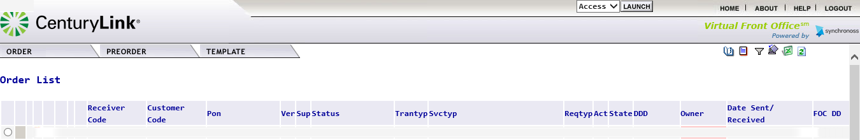  An EASE Administrator will see the following information:  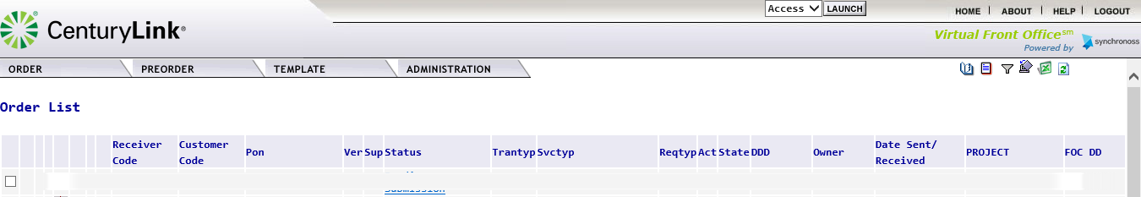  The screen differences are:  - An additional column of PROJECT is now displayed  Instead of the radial button, Administrators will see boxes to the left-hand side of the PON. When the item is selected, a check mark () will be displayed.

Replacement of Radial Buttons | Administrators will also notice that the radial button has been replaced by a check box. This will occur throughout the order screen and order list screens.  Instead of the radial button, Administrators will see boxes to the left-hand side of the PON. When the item is selected, a check mark () will be displayed.

ADMINISTRATION TAB

Overview | EASE VFO has enhanced capabilities for a user that has been defined as an Administrator. This is to allow the Administrator to control EASE VFO access for a specific ESP (Exchange Service Provider).  The ADMINISTRATOR tab will only display if a user’s profile has been set up as an Administrator. Within the Administrator tab, you will see the option for Security.  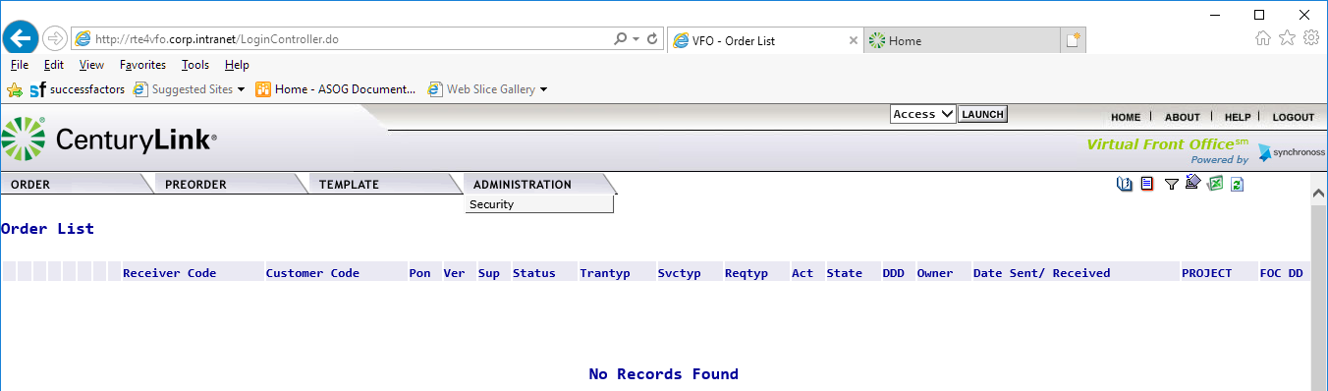

The Security Home Page | When you click on the Security option, the Security Home screen will be displayed.  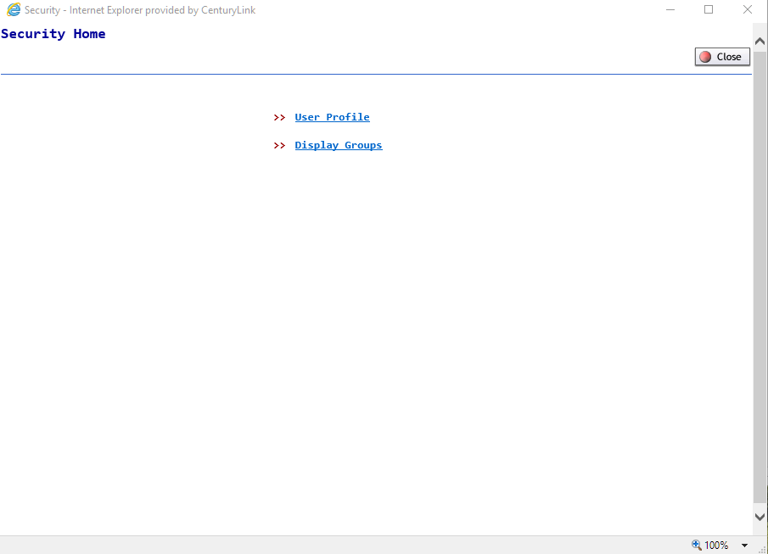  The Security Home screen has 2 options:  Option Description  User Profile Used to Create a new user profile or Change / Delete an existing user Profile  Display Groups Manage bulk profiles assigned to a user group

User Profile | The User Profile option allows an Administrator to  - Add a new user profile  - Change an existing user profile  - Delete a user profile.  When this option is selected, the User Profile Search List will be displayed. All existing users will be displayed on alphabetical order, with each screen display 100 results.  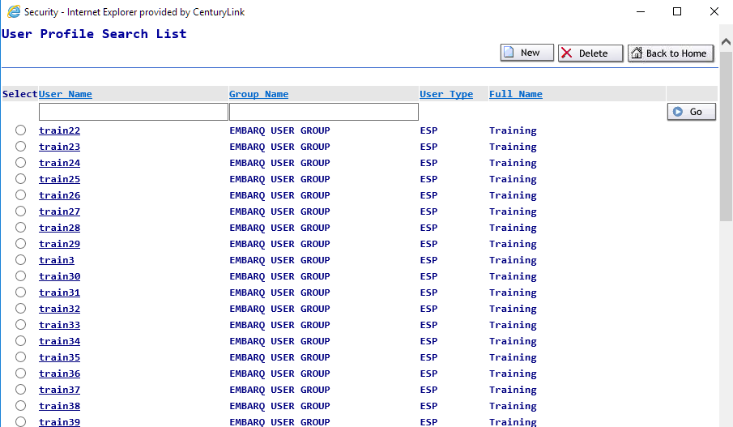  Administrators can use the scroll bar on the right-hand side to browse thru the users.  Additional pages can be accessed by clicking on the hyperlink associated to the Result Pages:

Searching for a specific user or group | Administrators can search for a specific user/group by entering the user name in the search boxes at the top. To use this option, follow the steps below:  Step Action  1a To search for a specific User Name, enter the information in the User Name box.  1b To search for a specific Group Name, enter the information in the Group Name box.  2 Click the button on the right-hand side of the screen.  3 The system will return the matching information

Using a wildcard in the search | Administrators can use the % sign to wildcard part of the search criteria. The system will return all matches based on the entered information.  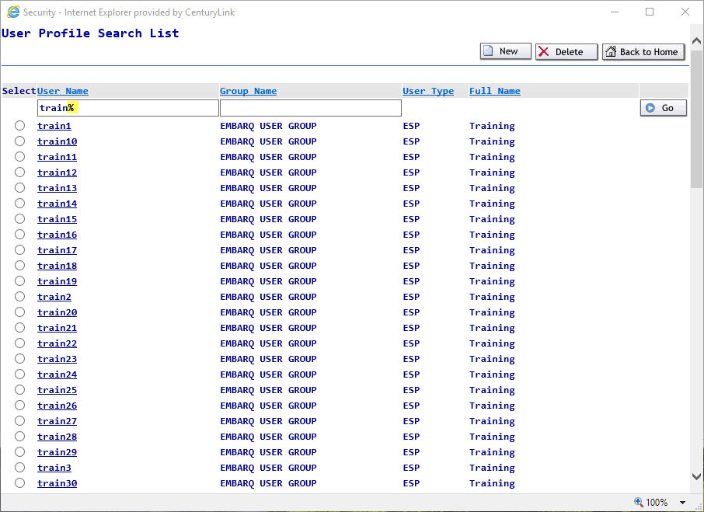

Password Rules | Within EASE VFO there are some basic password rules to follow. These rules are also available by clicking on the hyperlink Password Rules within the User Profile Details screen.  Passwords chosen must  - Be at least 8 characters in length but not more than 16 characters  - Contain at least one character from any three of the following four categories  - Uppercase alphabets (A-Z)  - Lowercase alphabets (a-z)  - Numbers (0-9)  - Special Characters (~ ` ! @ # $ % ^ & * ( ) - _ = + [ ] { } \ | ; : ' " , . < > / ?)  Passwords chosen must not  - Contain a space  - Be “password’ itself (case insensitive)  - Be same as the login user name  - Be the same as the 5 previously save passwords.

Adding a New User | EASE VFO Administrators can create accounts for other Administrators and for basic users within your company. Before you attempt to create a new user profile, make sure you have the necessary user information.  To add a new user, use the following steps:  Step Action  1 From the User Profile Search List, click on the New button in the top right-hand corner of the screen.  2 A new window will be opened for the User Profile Details.  3 Enter the information in each applicable field. Please Note: Fields marked with ‘*’ are mandatory Field Description User Name* This will be the assigned user name that will be used to log into the EASE system. User Names must be globally unique within the ESP. Duplicate User Names are not permitted. Password* The user’s password Please Note: Users can click on the hyperlink Password Rules to open a pop-up window detailing the current Password Rules. Confirm Password Re-enter the password information. Full Name This will represent the full name of the user. Designation An option field to describe the user profile Locked The user has entered an incorrect password too many times and the account has been suspended. Active The user has been logged into the system within the past 90 days. Force Reset The user is prompted to change the password to his/her liking, after the Administrator has reset the password. Password Never Expires This will allow the user to keep the assigned password while the user is active. Allow Submit with Errors This will allow the user to submit orders if errors are present in the EASE VFO system. This option should be limited to Administrators only. User Type* Use the drop-down to select an option Please Note: The value(s) available in the User Type drop down menu is determined by your profile configuration. You cannot assign a user type other than the one you have been assigned. Esp Name Use the drop-down to select an option. Managing ESP Branding Use the drop down to select an option Phone The phone number associated to the user Email ID The email associated to the user Select Group Primary Group* Select a group from the options listed and click on the right-pointing arrow to move that option to the Primary Group. Secondary Group If you wish the user to belong to a Secondary Group, select another group and click on the right-pointing arrow that corresponds to the Secondary Group field to add the privileges associated with the group. This will give the user the privileges of both groups.  4a Click the Save button to create the new user profile.  4b Click the Back to List button to exit the User Profile Details screen and return to the User Profile Search List screen. The user profile will not be created.  4c Click the Back to Home button to exit the User Profile Details screen and return to the Security Home screen. The user profile will not be created.  5 If the password and confirm password fields do not match, users will receive the pop-up box below. To correct this issue, Administrators should re-enter the information in the Password and Confirm Password fields prior to clicking on the Save button.  6 Upon successful creation of the new user, Administrators will be returned to the User Profile Search List Screen. A message *Successfully created the record will display under the Status: field. The newly created ID will be displayed alphabetically within the user list.

Modifying an Existing User | To modify an existing user, use the following steps:  Step Action  1 Administrators can search for a specific user by entering the user name in the search box and clicking the button. Please Note: User Names will be alphabetically listed on the User Profile Search List. Administrators can also view the list to select a user profile. Please Note: User Names will be alphabetically listed. Users may need to navigate to additional pages depending on the number of users.  2 A new window will be opened for the User Profile Details.  3 Alter the information in any of the User Profile details.  4a Click the Save button to modify the user profile.  4b Click the Back to List button to exit the User Profile Details screen and return to the User Profile Search List screen. Changes to the user profile will not be saved.  5 If the password and confirm password fields were altered and do not match, users will receive the pop-up box below. To correct this issue, Administrators should re-enter the information in the Password and Confirm Password fields prior to clicking on the Save button.  6 After clicking the Save button, Administrators will be returned to the User Profile Search List Screen. A message *Successfully updated the record. will display under the Status: field.

Resetting a Locked User | The following steps should be used to reset a Locked User.  Step Action  1 After several attempts of entering an incorrect password, the user will receive the message “Your account is locked due to excessive invalid login attempts. Please contact your Administrator to get your account unlocked”  2 Administrators can search for a specific user by entering the user name in the search box and clicking the button. Please Note: User Names will be alphabetically listed on the User Profile Search List. Administrators can also view the list to select a user profile.  3 A new window will be opened showing the User Profile Details. Administrators will notice a check mark in the Locked field.  4 Administrators will need complete the following: Step Action 1 Enter a temporary password in the Password and Confirm Password fields I Click on the Locked field to alter the status. The Locked field should be unchecked. 3 Ensure that the Force Reset field is also checked to require the user to reset the temporary password.  5a Click the Save button to modify the user profile.  5b Click the Back to List button to exit the User Profile Details screen and return to the User Profile Search List screen. Changes to the user profile will not be saved.  5c Click the Back to Home button to exit the User Profile Details screen and return to the Security Home screen. Changes to the user profile will not be saved.  6 If the password and confirm password fields do not match, users will receive the pop-up box below. To correct this issue, Administrators should re-enter the information in the Password and Confirm Password fields prior to clicking on the Save button.  7 After clicking the Save button, Administrators will be returned to the User Profile Search List Screen. A message *Successfully updated the record. will display under the Status: field.

Resetting an Inactive User | The following steps should be used to reset an inactive user.  Step Action  1 If a user has not logged into the EASE VFO system for over 90 days, the system will alter the active status. Users will receive the message “Your account has been deactivated since you have not logged in for at least 90 days. Please contact your administrator to activate your account.”  2 Administrators can search for a specific user by entering the user name in the search box and clicking the button. Please Note: User Names will be alphabetically listed on the User Profile Search List. Administrators can also view the list to select a user profile.  3 A new window will be opened showing the User Profile Details. Administrators will notice that the Active field is unchecked.  4 Administrators will need complete the following steps on the User Profile: Step Action 1 Enter a temporary password in the Password and Confirm Password fields 2 Click on the Active field to alter the status. The Active field will now display a check mark . 3 Ensure that the Force Reset field is checked () to require the user to reset the temporary password. 4 Ensure that the Locked field is unchecked.  5a Click the Save button to save the changes to the user profile.  5b Click the Back to List button to exit the User Profile Details screen and return to the User Profile Search List screen. Changes to the user profile will not be saved.  5c Click the Back to Home button to exit the User Profile Details screen and return to the Security Home screen. Changes to the user profile will not be saved.  6 After clicking the Save button, Administrators will be returned to the User Profile Search List Screen. A message *Successfully updated the record. will display under the Status: field.

Deleting an Existing User | To delete an existing user, use the following steps:  Action  1 Administrators can search for a specific user by entering the user name in the search box and clicking the button. Please Note: User Names will be alphabetically listed on the User Profile Search List. Administrators can also view the list to select a user profile  2 Click on the Delete button in the top right-hand corner of the screen.  3 Administrators will receive a pop-up window to confirm the deletion of the record.  4a Click OK to confirm the deletion of the user profile.  4b Click Cancel to exist the request and return to the User Profile Search List.  5 Administrators will receive a new message under the Status : field confirming the deletion of the user profile.  6 Administrators will be returned to the User Profile Search List screen.

EASE Password Reset Capabilities

Resetting the EASE User | An EASE user can have their user name/password reset by contacting the CenturyLink EASE helpdesk, their company specific EASE Administrator, or through the self-service security services.  Please Note: When first accessing EASE, users will be required to provide a valid email and establish answers to a set of security questions.

Setting up the EASE Self-Service User Reset option | Follow the below steps to use the self-service reset options in EASE.  Step Action  1 Initially, after providing a User Name and Password and clicking on Login, users will be redirected to a screen to establish security questions.  2 Users will need to select and answer 3 Security Questions.  3 For each security question (1, 2 and 3), Click on the drop-down arrow to display the available questions. Read through the various security questions and click on a specific question to select. Once the question has been selected, tab to the Answer field and enter a response.  4 Once all three security Questions / Answers have been provided, click on the to proceed to the next step.  5 Users will be prompted for a valid email address. If the user has been established with a valid email, the email will be pre-populated in the Email Address field. Users are asked to validate the information and provide a correction if necessary.  6 Click on the button.  7 EASE will generate a verification code to the provided email address.  8 Open the email and locate the unique verification code.  9 Enter the Verification Code in the field and click the button.  10 Users will be taken to the Order List on the EASE Main Menu.

Requesting assistance for a User Name | To request assistance for the User Name, use the following steps.  Step Action  1 Click on the Forgot User Name? hyperlink on the EASE Login Menu Screen.  2 Users will be taken to a new EASE Security screen where they can enter the Email Address associated with the User Name. Please Note: The Email Address is case sensitive and must match exactly.  3 Click the button. The user will be redirected back to the EASE Login Screen and will see the following message at the top “If your email address is associated with a user profile in the system, an email will be sent with the corresponding User Name(s). If you have entered a valid email address and do not receive an email within 10 minutes, please contact your Administrator”.  4 The user will receive an email detailing the User Name associated with the account.

Requesting Assistance for a Password | To request assistance for the password, use the following steps.  Step Action  1 Click on the Forgot Password? hyperlink on the EASE Login Menu Screen.  2 Users will be taken to a new EASE Security screen. Users will need to enter their User Name.  3 Click the button.  4 Users will be asked to answer one of the 3 security questions associated with the User Name.  5 After providing a response in the Answer field, press the button.  6 Users will be taken to the EASE password reset Login Screen. Please Note: The password must be unique from the previous 5 password entries associated to the User Name.  7 After providing a New Password, users should tab to the Confirm New Password field and re-enter the created password.  8 When both the New Password and Confirm New Password fields are entered, click the button.  9 Users will be returned to the main EASE Login Screen and see the message “You have successfully changed your password. Please login with the new password” in the top left-hand corner of the screen.  10 Login using the User Name and updated password.

EASE Home Page Icons | A new ICON has been added to the EASE Home Page ICONs called User Profile.  EASE Home Page ICONs  The upper right-hand corner of the VFO Home Page has 7 action icons to select.  ICON DEFINITION  User Profile – provide a link to the User Profile details. Users can use this link to reset their profile email, password and security questions.  History – provides a detailed history of an order, including Errored, Confirmed, Clarification, Jeopardy, DLR/Design, Completed, etc.  Create Response – allows user to create a manual response such as a Jeopardy or Clarification for a selected order  Filter – provides a way to filter orders from the order list. Clicking this ICON prompts another screen to open and requires the user to filter the criteria. Once filtered, user must clear the filter to return the order list to default view.  Return to Default Sort – allows user to return the order list to the default sort order  Export to Excel – exports an order selected from the Order List into an excel document  Refresh – Refreshes the Order List to show the latest order activities including new orders and updates to existing orders. This is NOT used to clear a filter or a sort, but only to update the Order List

Managing the User Profile | Users will have the ability to modify some attributes on their EASE user profile such as Password, Confirm Password, Email Address and Security Questions/Security Answers.  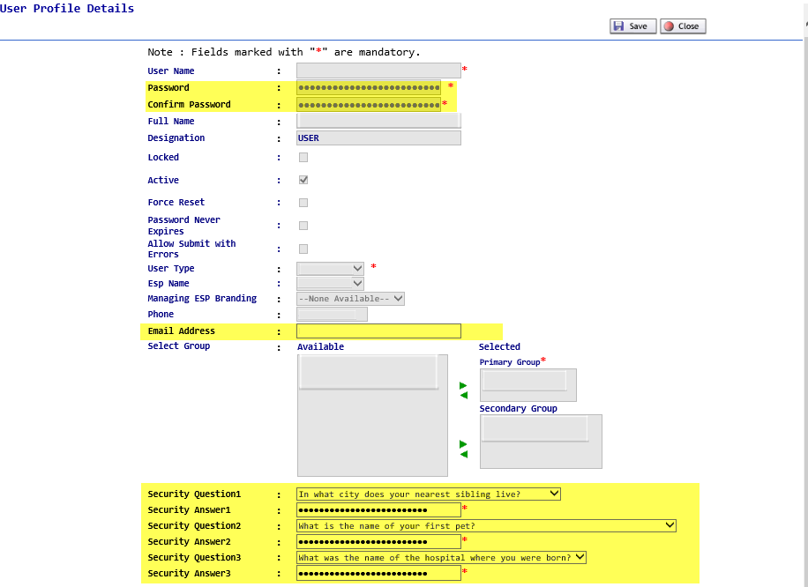

Modifying the User Profile Information | To modify the User Profile Information:  Step Action  1 Click on the User Profile ICON from the EASE Main Menu to access the User Profile Information.  2 Users can alter the following information: - Password - Confirm Password - Email Address - Security Questions/Answers  3 When finished, click on Save to keep the modified information Close to exit the User Profile without any modification.

Display Groups | The Display Groups option allows an Administrator to create a way to filter the Order List.  When this option is selected, the Display Group Search List will be displayed. All existing groups will be displayed on alphabetical order, with each screen display 100 results.  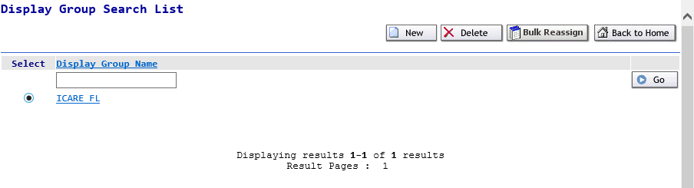

Searching for a specific Display Group | Administrators can search for a specific Display Group by entering the name in the search boxes at the top. To use this option, follow the steps below:  Step Action  1 To search for a specific Display Group Name, enter the information in the Group Name box.  2 Click the button on the right-hand side of the screen.  3 The system will return the matching information.

Using a wildcard in the search | Administrators can use the % sign to wildcard part of the search criteria. The system will return all matches based on the entered information.

Creating a New Display Group | As a EASE VFO Administrator, you can create Display Groups.  To add a new Display Group, use the following steps:  Step Action  1 From the Display Group Search List, click on the New button in the top right-hand corner of the screen.  2 The Display Group Details window will be opened.  3 Enter the information in each applicable field. Please Note: Fields marked with ‘*’ are mandatory Field Description Display Group Name* This will be the assigned Display Group Name. Description This is a field to further define what the display group is used for. Users This will show users who are Available to be assigned to a group and who have been Selected to a group. To move the user to the group, click on the user name and use the right arrow () to add the user to the Selected column. Please note: To select more than one user at a time, please hold down the CTRL key and click on the user name.  4a Click on the Back to List button to exit the Display Group creation and return to the Display Group Search List Screen.  4b Click on the Back to Home button to exit the Display Group creation and return to the Security Home Screen.  4c Click on the Save button to create the Display Group creation and return to the Display Group Search List Screen. The created group will appear in alphabetical order on the screen.

Modifying a Display Group | As a EASE VFO Administrator, you can add or remove users to an existing Display Groups.  To modify a Display Group, use the following steps:  Step Action  1 From the Display Group Search List, click on the Display Group name to be modified.  2 The Display Group Details window will be opened.  3 Administrators can modify any of the information in the fields on the screen. To add a new user to the group, locate the user name in the Available column and click on the right-hand arrow () to move the user to the Selected column. To remove an existing user from the group, locate the user name in the Selected column and click on the left-hand arrow () to remove the user.  4a Click on the Back to List button to exit the Display Group creation and return to the Display Group Search List Screen.  4b Click on the Back to Home button to exit the Display Group creation and return to the Security Home Screen.  4c Click on the Save to create the Display Group creation and return to the Display Group Search List Screen.

Bulk Reassign | As a customer EASE Administrator, you can bulk reassign Display Groups.  To Bulk Reassign, use the following steps:  Step Action  1 From the Display Group Search List screen, click on Bulk Reassign button.  2 The Bulk Reassign Display Group Users screen will be opened.  3 Use the drop-down menu to select a group in the From Group Column and the To Group Column. Please Note: If the From Group contains no users, users will receive pop-up message:  4a Click on the Back to List button to exit the Display Group creation and return to the Display Group Search List Screen.  4b Click on the Back to Home button to exit the Display Group creation and return to the Security Home Screen.  4c Click on the Save to bulk reassign the Display Group and return to the Display Group Search List Screen.  5 Administrators will receive a new message under the Status : * Reassigned Successfully. confirming the Bulk Reassign of the Display Groups.

Deleting a Display Group | To delete a Display Group, use the following steps:  Action  1 From the Display Group Search List screen, locate and click on the radial button to the left side of the Display Group Name. Please Note: Display Groups will be alphabetically listed. Administrators may need to navigate to additional pages depending on the number of users.  2 Click on the Delete button on the top right-hand corner of the screen.  3 Administrators will receive a pop-up window to confirm the deletion of the record.  4a Click OK to confirm the deletion of the Display Group profile.  4b Click CANCEL to exit the request and return to the Display Group Search List.  5 Administrators will be returned to the Display Group Search List screen.

